**Financial Arithmetic**

Simple Interest: Total Proceed = Principal x (1 + interest rate x (days/year))

Compound Interest: Total Proceed = Principal x (1 + interest rate x (days/year))N

Nominal and Effective Rates: Total Return = Principal x (1 + (interest rate/n))N

Effective rate = [(1 + (nominal rate/n))n - 1], nominal rate = [(1 + effective rate)1/n - 1] x n

**@Ex**. 1) 5% is the nominal interest rate quoted for a 1-year deposit when the interest is paid all at maturity. What the quarterly equivalent? [(1.05)1/4 - 1] x 4 = 4.91%

2) The interest rate for a 5-month (153-day) investment is 10.2%. What is the effective rates? Effective rate = (1 + 0.102 x 153/365)365/153 – 1 = 10.50%

Effective Rate = (1 + nominal rate x days/year)365/days - 1

Continuous Compounding: Daily equivalent rate – Equivalent rate with daily compounding for an annual rate of 9.3% [(1 + 0.093)1/365 - 1] x 365 = 8.894% continuously compounded rate = LN(1.093) = 8.893%. Continuously compounded rate = 365/days x LN(1 + days/year) where I is the nominal rate for days, or I = year/days x (er x days/365 - 1)

Future Value (FV) / Present Value (PV):

Short-term investments: FV = PV x (1 + i x days/year), PV = FV / (1 + i x days/year)

Yield/Rate of Return: For short-term investments yield = (FV/PV - 1) x year/days, effective yield = (FV/PV)365/days - 1

Long-Term Investment: FV = PV (1 + i)N, PV = FV / (1+i)N, yield = (FV/PV)1/N – 1

**@Ex**. I invest $138 now. After 64 days I receive back a total (principal + interest) of $139.58. What is my yield on this investment? yield = (139.58/138.00 - 1) x 365/64 = 0.0653 = 6.53%

Discount Factors: PV = FV x Discount Factor

For simple interest: Discount Factor = 1 / (1 + I x days/year)

For compound interest: Discount Factor = (1 / (1+i))N

**@Ex**. What is the 3-year discount factor based on a 3-year interest rate of 8.5% compounded annually? Discount factor = 1 / (1 + 0.085)3 = 0.7829

What is the present value of $100 in 3 years time? $100 x 0.7829 = $78.29

Net Present Value: NPV = sum of all the present values

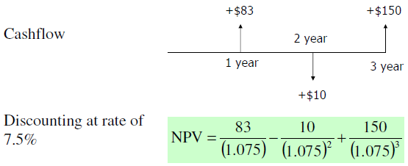

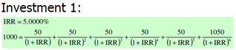

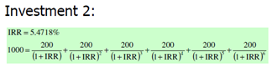

Annuity: a regular stream of future cash receipts which can be purchased by an initial cash investment. yield = Internal Rate of Return

**Money Market**

1. **DAY/YEAR conventions**



Most money markets use ACT/360

Exceptions using ACT/365:

**International and domestic: S**terling, Hong Kong dollar, Singapore dollar, Malaysian ringgit, Taiwan dollar, Thai baht, South African rand

**Domestic (but not international):** Japanese yen, Canadian dollar, Australian dollar, New Zealand dollar

1. **Eurodeposit**

Round-the-clock business spanning Singapore and Hong Kong, Bahrain, Frankfurt, Paris, London and New York

LIBOR – the rate dealers charge for lending money (they offer funds)

LIBID – the rate dealers pay for taking a deposit (they bid for funds)

In London, quote (offered rate – bid rate) Other places, quote (bid rate – offered rate)

**Rule:** pay the higher rate for a loan, receive the lower for a deposit

1. **Fixed Date Conventions**

**End/End Rule:** If the spot date is a month-end, then all forward fixed dates will be month end

**Month-End Roll Back:** If the forward date lands on a month-end and that happens to be a weekend or a holiday, then it cannot be rolled forward to the next month. Settlement will be rolled back to the last working day of the same month

**@Example**: A two-month Eurodeposit booked in London on 26 February will be for value 28 February, the spot date. Since this a month-end, the deposit will mature on 30 April. If 30 April is a Sunday, the deposit will mature on 28 April.

1. **Certificate of deposit (CD)**
2. **Pricing** Price = present value

Consider CD paying only one coupon at maturity:





1. **Return**

 



**@Example: issuer** XYZ **rating** A1P1 **issue date** 1 January 2007 **maturity** 1 January 2008 **face value** $1,000,000 **interest** 5% pa



Now only 61 days left to maturity and current 2 month deposit rates are 4% 

You are offered $1,042,800 for the CD. What yield does this represent? 



Secondary market price quote is 4.13%

**@Example CD – quoted price:** If you were quoted 4.13 – 3.89 for the 5% XYZ CD, this means that the market maker is willing to buy it from you for a cash amount that will give him a yield 4.13%, or he will sell it to you for a cash sum that will yield you 3.89%

**@Example Discount rate quote:** The quoted rate on a US T-bill with 50 days to maturity is 4.12% (discount basis). How much would you have to pay for the bill, for a $1,000,000 deal?





1. **Discount to Yield Conversion**









**FRAs & IRF**

**FRA**

1. Calculate forward rate

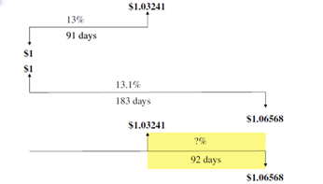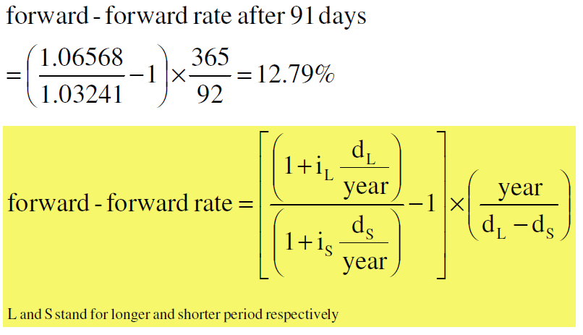

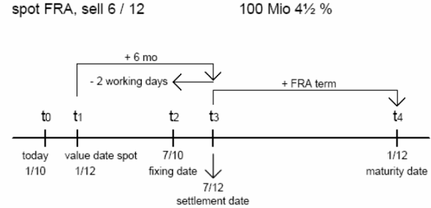

**@FRA example:**

If FRA rate > reference rate: bank pay for customer; Else customer pay for bank.

1. How to figure out the FRA price: given the rate of 6 month and the rate of 12, calculate the forward rate from 6 to 12.
2. No free lunch principal: buyer deal at higher rate, seller deal at lower rate.

**Futures:**

**Def**: A contract in which the commodity being bought or sold is considered as being delivered (may not physically occur) at some future date.

**Characteristics**: [1]Exchange traded (vs OTC in “forward”). [2] Pricing depends on underlying commodity

**Price of futures:** 100 – interest rate*100. E.g: 100- 0.03*100 = 97

Profit and loss: Profit/loss on long position in a 3-month contract

**Hedging FRA with Futures:** sell a 3v6 FRA for $10m, FRArate=8.25%, Future rate=8.25%



**Profit or loss on sold futures** 



3 v 9 FRA = a strip combining 3 v 6 FRA and 6 v 9 FRA, **so** 3 v 9 FRA rate

**@Example:**

Given market prices:

2 v 5 FRA 7.22 / 7.27%; 3 month futures 92.67 / 92.68, futures delivery date is in 2 months time

Any must win strategy: buy-buy

**@Example:**

If trader expects interest rates to rise, he will ***sell futures*** contract.

If trader expects rates to fall, he will ***buy futures***.

***@Example*:**

If interest rates rise: buyer of FRA will win; buyer of futures will lose

If a trader sells an FRA to a counterparty: he should ***sell*** futures to cover his position

**Interest Rate Swaps (IRS)**

Similar to FRA: No exchange of principal;Only interest flows are exchanged and netted

Different from FRA: Settlement amount paid at the end of relevant period

**Motivation**

|  |  |  |  |
| --- | --- | --- | --- |
| Company | Fixed | Floating | Prefer |
| A | 8.0% | LIBOR+0.1% | Floating |
| B | 9.5% | LIBOR+0.8% | Fixed |

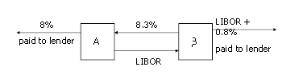

3-month LIBOR 14.0625% (91 days)

FRA 3 v 6 12.42% (91 days)

6 v 9 11.57% (91 days)

9 v 12 11.25% (92 days)

FRAs and IRS

Consider the following:

• Borrow USD 1 now for 3 months. At end of 3 months, repay:

USD(1+0.140625* 91/365)= USD 1.03555

• Borrow USD 1.03555 and use FRA 3 v 6. Assume repayment at the end of 6 months:

USD(1.03555+0.1242* 91/365)= USD 1.06806

• Borrow USD 1.03555 and use FRA 6 v 9. Assume repayment at the end of 9 months:

USD(1.06806+0.1157* 91/365)= USD 1.09929

• Borrow USD 1.03555 and use FRA 9 v 12. Assume repayment atthe end of 12 months:

USD(1.09929+0.1125* 92/365)= USD 1.13090

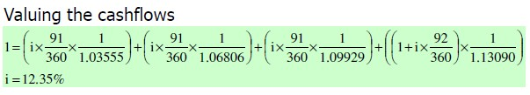

**Valuing swaps**

Value the following IRS on 27 March 2002

Notional amount: 10 million

Start of swap: 23 July 2001

Maturity of swap: 23 July 2004

Receive: 7.4% (annual 30/360)

Pay: LIBOR (semi-annual ACT/360)

Previous LIBOR fixing: 9.3% from 23 Jan 2002 to 23 Jul 2002

Zero-coupon discount factors from 27 Mar 2002:

23 Jul 2002: 0.9703 23 Jan 2003: 0.9249

23 Jul 2003: 0.8825 23 Jan 2004: 0.8415

23 Jul 2004: 0.8010

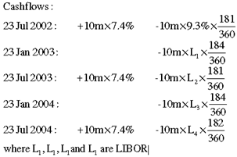

**Curve**

**(1)Yield Curve**: Market rate of interest for theoretical zero coupon instruments that Mature at any future date. It derived from prices of real financial instruments that trade in a liquid market.

**(2)Input points**: Liquid market instruments don’t exist for every date in future.

**(3)Benchmark set or key points**: 1.cash rates: ON, TN, 3M, 6M, 1Y; 2.Swaps Rates: 2Y, 3Y, 10Y; 3.Liquid number of futures contract

**(4)Discount factor & Forward rate**:

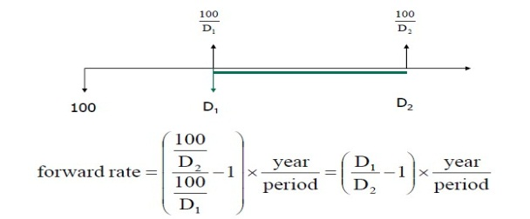

**(5)Cash**: **e.g**. Cash rates on 8 March 2007(Thursday, Base date): ON=0.57%, TN=0.57%, 3M=0.70625%. Basis is ACT/360, Number of days to spot is 2.

(a)ON(Key Point 1) Discount factor for day 1(Friday, 9 March)

(b)TN(Key Point 2) spot business day after basic day. Discount factor

(c)3M cash rate ended on? Discount factor

**(6)Future (Excel Assignment)**: relationship discount factors 1st and 2nd future contract:

Given 2 points x1 and x2 and a point x between them. We assume that (x1,y1) and (x2,y2) lie on the curve.

(k, m are constants)

Solving for k and m:  

Swaps(Excel Assignment): **eg**. 3-year swap priced at 1.05625% against 6-month LIBOR. Spot, at 2 business days, Monday, 12 March 2007.

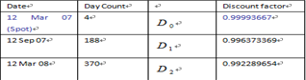

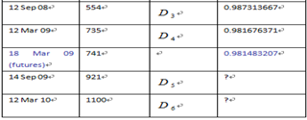

The fixed leg cashflow must satisfy the following:

 

**Binomial Tree:**

(1)Options: Call(Put) option gives the holder the right to buy(sell) the underlying asset by a certain date for a certain price.

*European* options can be exercised only on the expiration date.

*American* options can be exercise at any time up to the expiration date.

(2)One-Step Binomial Model: **eg.** European call option to buy stock for $21 at the end of 3 months.

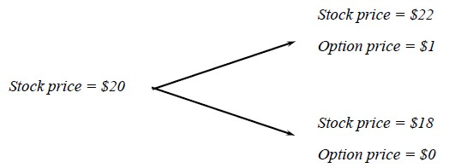

Riskless Portfolio: Long: Δ share Short: 1 option

The portfolio is riskless if the value of Δ is chosen such that the portfolio is the same for both of the alternative stock prices: 22Δ -1=18Δ Δ=0.25

If the stock price moves up to 22(moves down to 18), the value of the portfolio in 3 months is 22*0.25-1=4.5 (18*0.25=4.5)

Suppose risk-free rate is 12% per annum, pv of portfolio is



Thus 20*0.25-Option Price=4.367 Option Price=0.633

Generalization: 

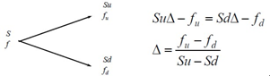

Derivative Price: the risk-free interest rate by r, pv of portfolio is Thus,  

Multi-steps Tree: 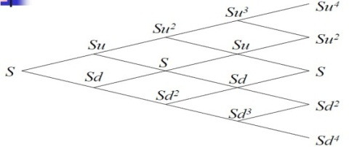

**VBA**

**\* Excel Object Model**

**[Object]**Worksheets("Object").ActiveCell**[Properties]**.Value

**[Object]** Worksheets("Object").Range("ClearContents") **[Method]**. ClearContents

**[Collections]**

Worksheets: worksheets in this workbook

Range: cells in Range("YellowCells")

**[Hierarchy]**

Application.Workbooks("vba_intro_ans.xls").Sheets("Object").Range("YellowCells")

**\*Operators**

**[Common Operators]** &, *, +, -, /, \, Mod, ^, =, And, Or, Xor, Not, Is

**[Comparison Operators]** <, <=, >, >=, =, <>

**\*Statements**

**[If…Then…Else]; [Selec Ctase]; [Do…Loop]**

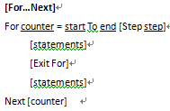 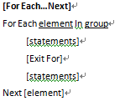

**\*Array**

**[fixed-size array] Dim** iFixedSizeArray(**10**) as **Integer**

**[dynamic array] Dim** iDynamicArray() as **Integer**

**[variant] Dim** vArray As **Variant**

**[Erase]** arraylist**;** fixed-size: reinitialize, recovers no memory

dynamic: frees memory

**[Array Copy]** anArray = iFixedSizeArray

Assign to dynamic **OK**; Assign to Variant **OK**; Assign to fixed-size array **NOT OKs**

**\*Sub & Function**

**[Sub]**

[Private | Public] [Static] **Sub** name [(arglist)]

[statements]

[Exit Sub]

[statements]

**End Sub**

**[Function]**

[Public | Private] [Static] **Function** name [(arglist)] [As type]

[statements]

[name = expression]

[Exit Function]

[statements]

[name = expression]

**End Function**

Ex1. Money market rates: 6-month 4.000%--4.125% 180days

12-month 4.375%--4.500% 360days

1. Calculate the highest 6V 12 FRA price, above which it is possible to make a risk free profit.
2. Calculate the lowest 6V 12 FRA price, above which it is possible to make a risk free profit.

Ans: a. Borrow $100 for 12 months at 4.5% b. Borrow $100 for 12 months at 4.375%

Lend $100 for 6 months at 4% Lend $100 for 6 months at 4.125%

Sell FRA 6V12 at Sell FRA 6V12 at

$\left(\frac{100*\left(1+4.5\%*\frac{360}{360}\right)}{100*\left(1+4\%*\frac{180}{360}\right)}-1\right)*\frac{360}{180}$ $\left(\frac{100*\left(1+4.375\%*\frac{360}{360}\right)}{100*\left(1+4.125\%*\frac{180}{360}\right)}-1\right)*\frac{360}{180}$

­­­

Ex2. Value the following IRS on 27 March 2002

Notional amount: 10 million

Start of swap: 23 July 2001

Maturity of swap: 23 July 2004

Receive: 7.3% (semi-annual 30/360)

Pay: LIBOR (semi-annual ACT/360)

Previous LIBOR fixing: 9.2% from 23 Jan 2002 to 23 Jul 2002

Zero-coupon discount factors from 27 Mar 2002:

23 Jul 2002: 0.9703 23 Jan 2003: 0.9249

23 Jul 2003: 0.8825 23 Jan 2004: 0.8415

23 Jul 2004: 0.8010

1. Show the cashflows of the fixed leg
2. From the zero-coupon discount factors, infer the market rates for the float-leg periods.
3. Using the market rates inferred in part b, calculate the cashflows of the float leg.
4. Calculate the NPV

Ans: a. 23 Jul 2002: 10,000,000*7.3%* 180/360 = 365000

23 Jan 2003: 10,000,000*7.3%* 180/360 = 365000

23 Jul 2003: 10,000,000*7.3%* 180/360 = 365000

23 Jan 2004: 10,000,000*7.3%* 180/360 = 365000

23 Jul 2004: 10,000,000*7.3%* 180/360 = 365000

b. 23 Jul 2002 23 Jan 2003 (0.9703/0.9249 -1)* 360/184=0.096039=L1

23 Jan 2003 23 Jul 2003 (0.9249/0.8825 -1)* 360/181=0.095560=L2

23 Jul 2003 23 Jan 2004 (0.8825/0.8415 -1)* 360/184=0.095327=L3

23 Jan 2004 23 Jul 2004 (0.8415/0.8010 -1)* 360/182=0.100012=L4

c. 23 Jul 2002: -10,000,000*9.2%* 181/360= - 462555.56

23 Jan 2003: -10,000,000*9.6039%* 184/360= - 488417.78

23 Jul 2003: -10,000,000*9.5560%* 181/360= - 480454.44

23 Jan 2004: -10,000,000*9.5327%* 184/360= - 487226.89

23 Jul 2004: -10,000,000*10.0012%* 182/360= - 505616.22

Fixed Floated Df NPV

d. 23 Jul 2002: 365000 - 462555.56 0.9703 -94658.16

23 Jan 2003: 365000 - 488417.78 0.9249 -114149.10

23 Jul 2003: 365000 - 480454.44 0.8825 -101888.54

23 Jan 2004: 365000 - 487226.89 0.8415 -102853.93

23 Jul 2004: 365000 - 505616.22 0.801 -112633.59

-526183.32

NPV=(fix-|float|)*discount factor 然后每一期相加

Ex3. Given the following market data input and WEL calendar(note that Saturdays are not business days)

Currency NZD Cash ON 7.25000%

Base Date 1-May-06 Cash TN 7.25000%

Days to Spot 2 Cash 3M 7.50500%

Cash Basis ACT/365

Futures Basis ACT/365 Futures 15-Jun-06 92.57

Swaps Basis ACT/365 Futures 14-Sep-06 92.72

Swaps Freq Semi-Annually Futures 14-Dec-06 93.00

Holiday WEL

Swaps 1Y 7.27600%

a. Identify the dates for the Cash key points and calculate the discount factor for the key points.

b. Identify the starting future date and use exponential interpolation to calculate the discount factor for the starting future date.

c. Identify the dates of key points for all futures and calculate the discount factor for all futures key points. Given 15 Mar 07 is the date for the last futures key point.

d. Identify the date of the key point for the 1Y swaps

e. Show the equation that the 1Y swaps has to satisfy.

f. Calculate the discount factor for the 1Y swaps key point.

Ans. a. 2 May 06 $1/{1+(0.0725 * 1/{365})}$ = 0.999801409

3 May 06 ${0.999801409}/{1+(0.0725 * 1/{365})}$ = 0.999602858

3 Ang 06 ${0.999602858}/{1+(0.07505 * {92}/{365})}$ = 0.981044717

b.15 Jun 06 : $0.999602858*{{(0.981044717}/{0.999602858)}}^{42/92}$

= 0.990885648

c.14 Sep 06 $0.990885648/\left\{1+{[ \left({100-92.57}/{100}\right)}/{\left( {91}/{365}\right)}]\right]$ = 0.972864205

14 sep 06 $0.972864205/\left\{1+{[ \left({100-92.57}/{100}\right)}/{\left( {91}/{365}\right)}]\right]$ = 0.955521362

15 mar 07 $0.955521362/\left\{1+{[ \left({100-93}/{100}\right)}/{\left( {91}/{365}\right)}]\right]$ = 0.939131586

d. 3 May 07 在spot day 后推一年

e. (- 100* 0.999602858) + (100*7.276% ${184}/{365}$**0.963296569) + (100+100*7.267% ${181}/{365}$**D) = 0

f. 0.939131586

Ex4. Transfer VBA data to and from Worksheet.

Given an array with data as follows:

Dim dArray(1,3) As Double

dArray(0,0) = 1: dArray(0,1) = 2: dArray(0,2) = 3

dArray(1,0) = 4: dArray(1,1) = 5: dArray(1,2) = 6

a. Write one statement to transfer the array to the range B2:D3

b. Write one statement to clear dArray, that is, fill dArray with 0s.

c. Write code transfer data form “data2X3”, a 2X3 named range to dArray.

Ans. A. Range(“B2:D3”) = dArray

B. Erase dArray

C. For i = 0 to 1

For j = 0 to 1

dArray(i, j) = Range(“data2X3”).Cells(i+1, j+1)

Next j

Next i

Ex5. True or False

a. In an IRS, one will gain while the other will lose.

F. Two can benefit each other.

b. Given a 5% nominal interest rate quoted for a 1-year deposit when the interest is paid all at maturity. The quarterly equivalent rate should be less than 5%.

T.

c. A zero coupon instrument A is quoted at discount basis of 5%. Another zero coupon instrument B is quoted at a yield basis of 5% with the same maturity as A. Instrument B has a better return.

F.

d. If a trader sells an FRA to counterparty, he should by futures to cover his position.

F.

e. A flat yield curve indicates that the interest rate will drop in the future.

T.

Ex6. Excel

a. Formula

Show the formula for the received fixed leg for 12-Sep-07. Your formula should be able to copy and paste to the rest of the cashflows.

=$B$1 * $C$6 * B10 / 365

notional* Swaps* days/years

b. Function

Given the following PMT function description from Excel:

PMT(rate, nper, pv)

Rate is the interest rate for the loan.

Nper is the total number of payments for the loan.

Pv is the present value, or the total amount that a series of future payments is worth now, also known as the principal.

For a home loan of $3,000,000 and an annual rate of 5%, in terms of PMT, the monthly payment for a loan term of 20 years.

PMT(5%/12, 240, 3000000)